
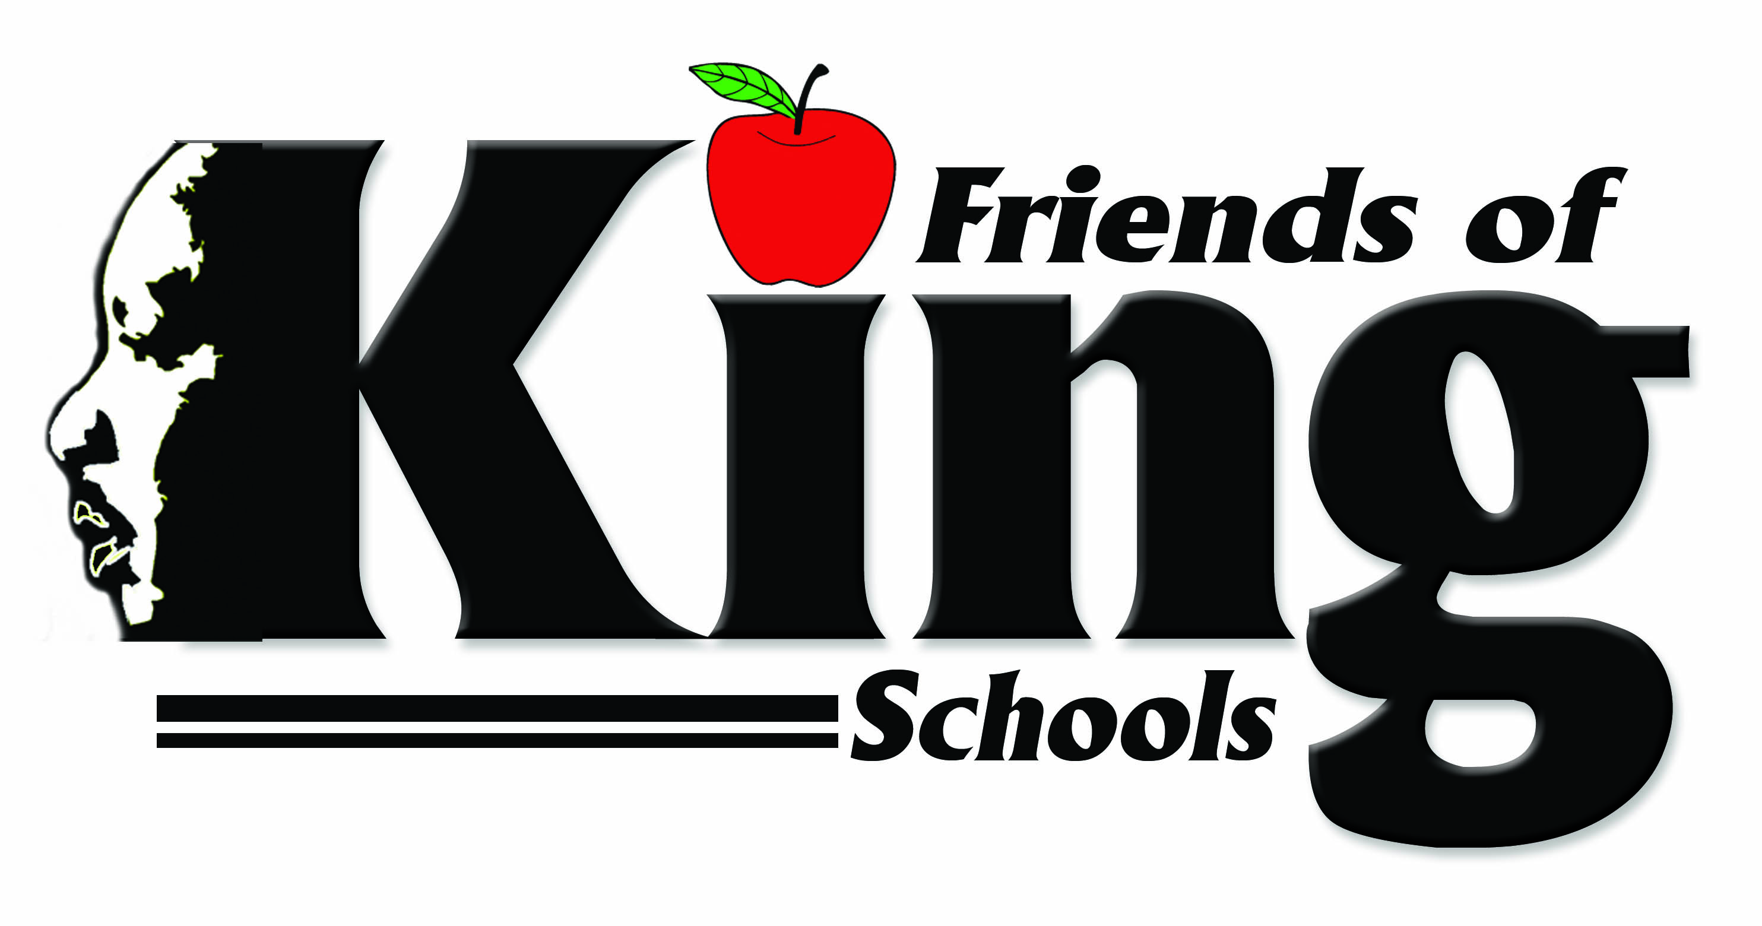

Dear Future Jaguar,

On behalf of Friends of King School District, Dr. Martin L. King, Jr. Charter High School, family, and the community, it is truly a pleasure to send warm and heartfelt wishes your way! I pray that this letter finds you and your family blessed, in good health, and in good spirit.

On that same note, I want to personally thank you for choosing us and welcome you and your family to Dr. Martin Luther King, Jr. Charter High School! You are about to begin one of the most exciting times in your life and we all want to make sure that you receive a King-size education and fond memories. At KHS, we take your education very seriously and we want you to do the same! Please know that Dr. Lindsey Moore Sr., principal is always available to you, and I encourage you to contact him for any reason, at any time. You may do so at lmoore@mlknola.org or 504.325.2179.

KHS is a special place! Our spirit, traditions, diversity, commitment to academic excellence, as well as our dedicated staff contribute to making King High a great choice to continue your academic successes. We want you to enjoy the campus and take full advantage of everything King High School offers. In doing so, we encourage you to join our many groups, clubs, organizations, and sports teams. #1KHSGOJAGS

Again, welcome to Dr. Martin Luther King, Jr. Charter High School and we look forward to you having a great KHS Jag Experience!

Kingfully,

Gloria Miles, Director of Admissions

“Committed to the Community - Dedicated to the Dream”

